**Homework #8 - Linux commands II**

**1. Elevate your user access to root;**

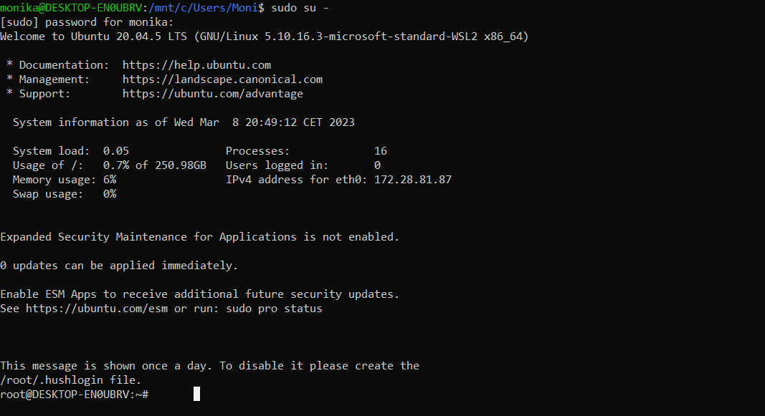

sudo su – to elevate your user access to root.

**2. Add a new user to your Linux OS and set a password for it.**

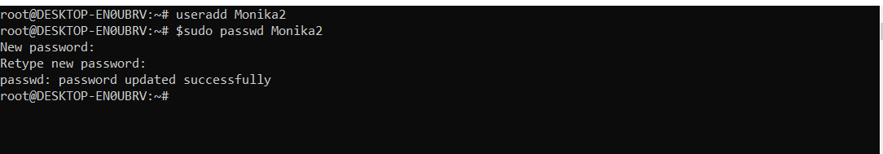

useradd <username> to add the user  
passwd <username> to update the password for the new user

**3. Test if you can log in using that user;**

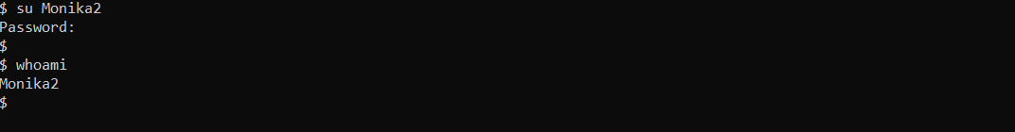

Su <username> Switching user so we can check if we can log in with the new username  
whoami checking which user is active

**4. Using grep command check if the user is created;**



grep <username> /etc/passwd This way we are checking the user ID and we can see that   
 Monika2 is already created

**5. grep the UID of each user.**

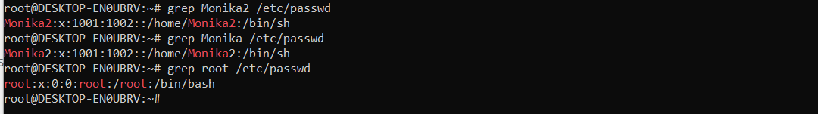

grep <username> /etc/passwd Checking the ID of each user

**6. Find out the GID of the created user;**

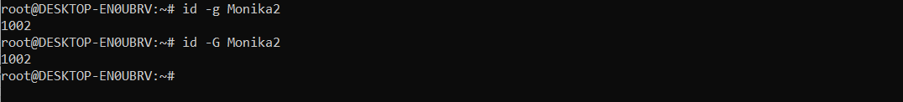

id –G <user> This way we are checking the group ID of the user

**7. Change the password of the user and force it to change the pass on his next login;**

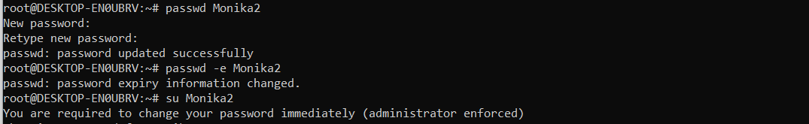

Passwd <username> the root is changing the user’s password  
passwd –e <username> the root is setting the password to “expire” so the user has to change it

**8. Add a new user and set an expiration date for it, with a five-day warning period;**

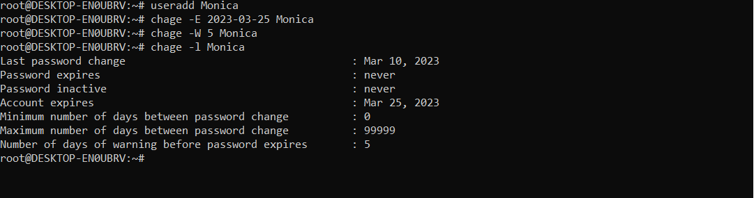

useradd We add a new user  
chage –E 2023-03-35 <user> We type –E (expiration) and the date when we want the user to expire   
chage –W 5 <user> We set –W (warning) 5 (number of days) and the user   
chage –l <username> We can also check if everything has been set up with this command

**9. Create a new group;**



groupadd <name of the group> command for creating a group

**10. Assign the two new users to that group;**



usermod –a –G <groupname> <user> assign to group and the names of the group and user

**11. Lock one of the user accounts;**



usermod -L Monica meaning lock that user <Monica>

passwd –S Monica meaning password status of user Monica and we can see L (locked) in the output

**12. Change the shell of one user to tcsh;**

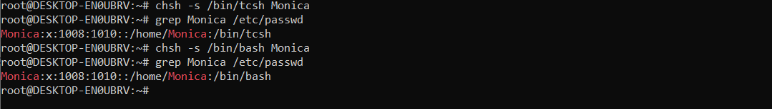

Chsh –s command is used to change the user’s shell attribute and by typing   
/bin/tcsh we instruct that the shell should be tcsh, and with  
grep <user> /etc/passwd we can check if the command was successful.

**13. Make sure your home directory has “execute” access enabled for group and other.**



cd to open the home directory

ls –ld ~/ to check the access

drwxr –xr-x meaning: directory – group – other and the directory as access to read, write and   
 execute permissions for the owner, but only read and execute permissions for the  
 group and for other users.

**14. Change to your home directory, and create a directory called labs;**

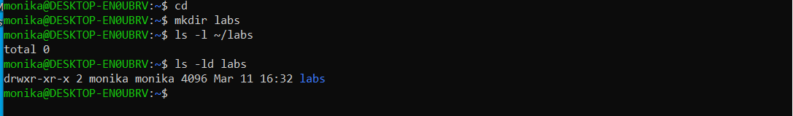

mkdir <name> mkdir is the command to make a new directory

ls –l ~/labs to list if the directory is created and we can see that is 0 – empty

ls –ld labs to list and check the access of the directory labs

**15. Create an empty file in labs directory**



touch <directory>/<name> this way we create an empty txt file in the labs directory and we check that  
 by listing the directory

**16. Change permissions of file to rwx-rwx-rwx**

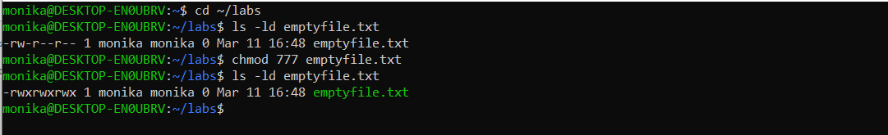

ls –ld to check the permissions that this file has  
chmod 777 <file_name> change mode to 7(rwx) 7(rwx) 7(rwx) and recheck the permissions

**17. List the file. What color is the file?**



As we can see on the previous picture the file was white color and now it has changed to green, meaning the request was executed.

**18. Change the permissions back to rx-rw-rw**



Chmod 0566 meaning 5 (user permissions) can read and execute ;   
 6(group permissions) can read and write and   
 6(other users permissions) and read and write.

**19. Check what owners does the file have.**



ls –l we can see that the owner of this file is Monika

**20. Change the user ownership of the file to another user;**

sudo chown <user> <file> sudo upgrades the privileges so we can change the ownership,   
 chown changes the owner of the file and we specify user and file

**21. Create a group called group1 and assign two users to the group;**

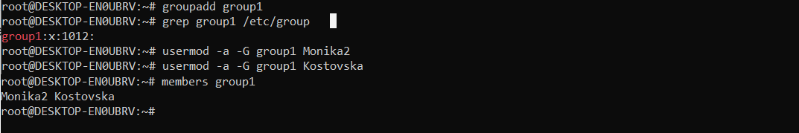

Groupadd <name> Creating a group

usermod –a –G <groupname> <user> meaning assign to group and the names of the group and user

members<group_name> members is command to check which user is in the group

**22. Create a file called group1.txt and redirect below input into the file: “This is our group test file”.**

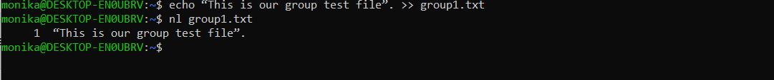echo <text> meaning print this text to   
>> group1.txt and we are creating new file group1.txt

nl group1.txt is another command to open the file, we can also use less, more, cat etc

**23. Change the group of the file to one of your users;**





Sudo chgrp <user> <group> for this we need root privileges and that is why we type sudo first  
chgrn change group name and we need to enter the username and the   
 group name.

**24. Give members of the group group1 read/write access to this file?**



Chmod 664 meaning 6(owner) will be able to read and write  
 6(group) will be able to read and write  
 4(other) will be able to read.